

System design SPECIFICATION
for
Manifest (Air, Road, passenger, Dispatch Challan)

Release No 2.0– May,2022

Document Identification no | Document Title | Status  (draft/ approved/ baselined/ released ) | Date of Release | Pages
eCMS /sds/01/V2.0 | System design specification for Manifest

Prepared By
Role | Name | Signature | Date (dd-mm-yyyy)

Reviewed by

Role | Name | Signature | Date (dd-mm-yyyy)

Approved By
Role | Name | Signature | Date (dd-mm-yyyy)
application system Manager

Authorized for Release
 | Name | Designation | Signature | Date (dd-mm-yy)
Authorized by Project Manager

Contents
1. INTRODUCTION 4
1.1 Scope 4
1.2 Definitions and abbreviations 4
1.3 References 5
1.4 Product Perspective 5
2. Design viewpoints 6
2.1 Interface viewpoint 6
2.2 Dependency Viewpoint 19
2.3 System Database Schema 20
2.4 Field Details 22

INTRODUCTION

The eCMS, as its name implies, will be a system for the DRC’s Customs & Excise Division, hereafter referred to as “Customs”, that will provide best-in-class services to the Bhutan‘s business community, in support of the Bhutan‘s aspirations to modernize core customs administration functions as part of customs modernization requirements and in line with the international conventions and national regulations such as The Customs Act of Bhutan 2017 and Customs Rules and Regulations of Bhutan 2017.

Implementation of the electronic customs management system will further help to propel Bhutan’s rankings by making it easier and clearer for traders and businesses to have access to information and enable them to submit regulatory compliance forms/documents digitally.

This document is intended to act as the SDD (Software Design Document) for the Manifest module.

Scope
This document defines & illustrates the business requirements, process flows as well as the detailed functional requirements of eCMS Application module (Authorized Compliant Trader and Exemption) to be implemented for Department of Revenue and Customs, Bhutan.

Definitions and abbreviations

S/N | Abbreviations | Description
 | BITS | Bhutan Integrated tax System
 | CFA | Clearing and Forwarding Agent
 | CID | Citizens Identification Number
 | DRC | Department of Revenue & Customs
 | eCMS | Electronic Customs Management System
 | Nu | Ngultrum
 | RRCO | Regional Revenue and Customs Office
 | RTO | Regional Trade Office
 | TPN | Taxpayer Number

References
Signed off SRS_eCMS_Registration_V1.0

Product Perspective

Design viewpoints

Interface viewpoint
The Interface design focuses on the screen designs for various services provided by the Manifest module.

Road Manifest
Header: The user creates a road manifest starting with the header data.

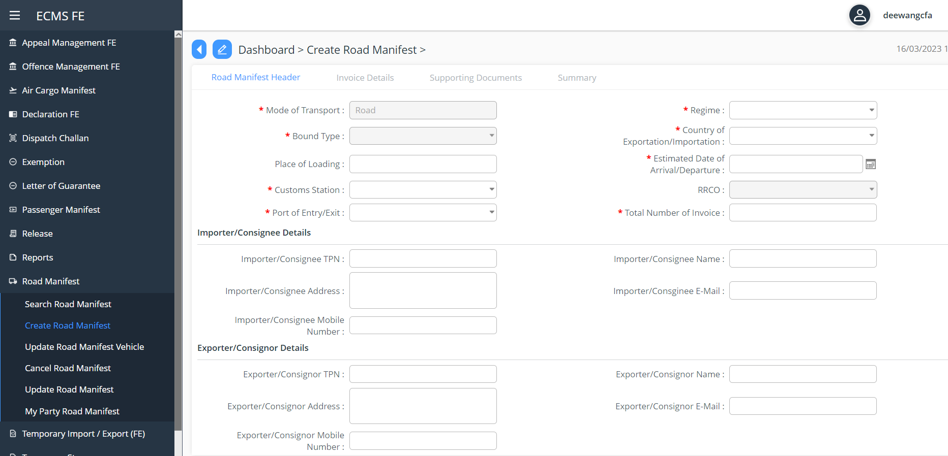

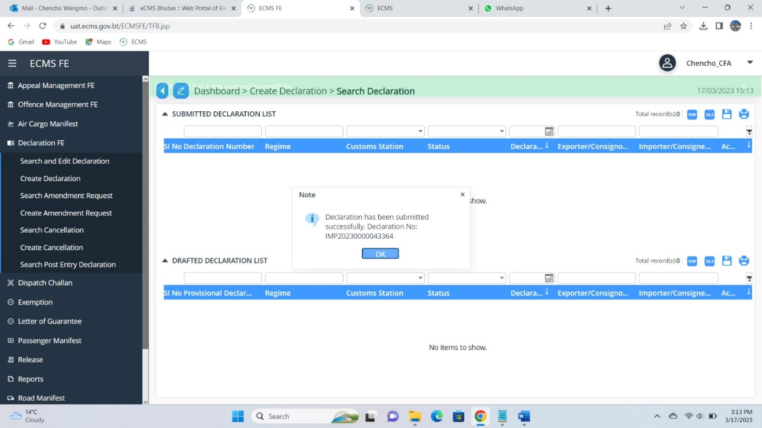
Screenshot for Creating Road Manifest

- Create Invoices

  - Create Invoices with Bulk Items
For Invoices with bulk items, the user can choose the Bulk indicator.
After entering all the mandatory inputs, the user can save the invoice data.

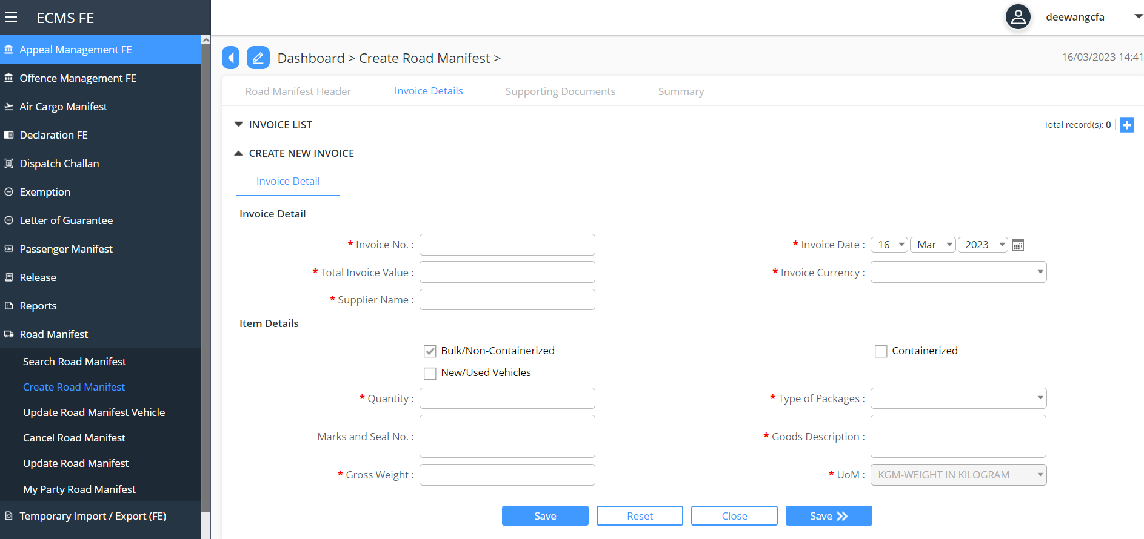
Screenshot for Invoice bulk Item

  - Create Invoice for Vehicle Items
The user can create invoices only after the header data has been saved. For Invoices with vehicle items, the user can choose the Vehicle indicator:
:
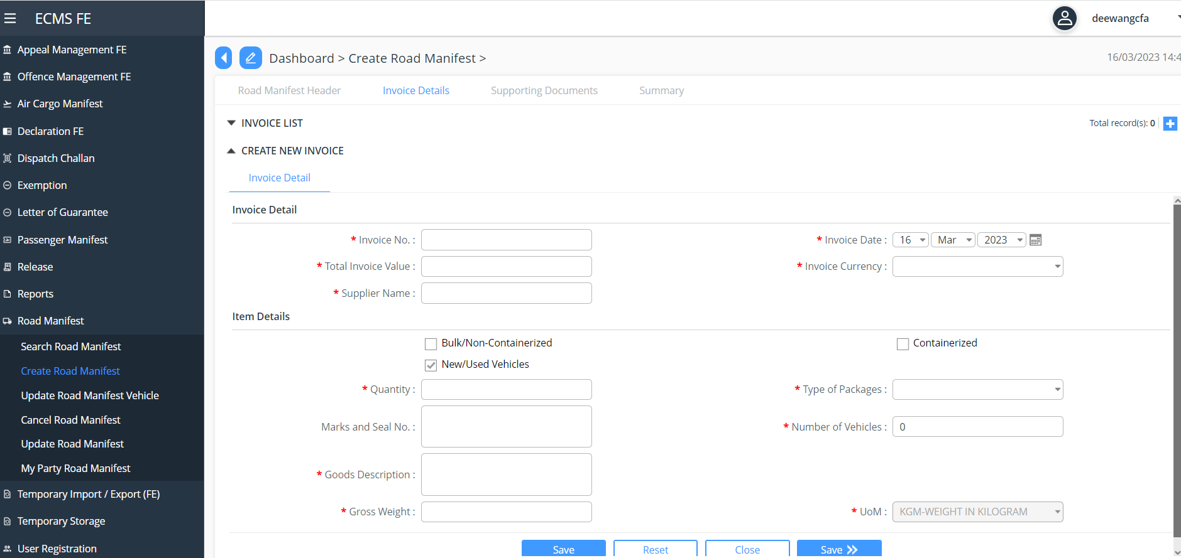
Screenshot of Invoice for Vehicle Items

  - Create invoice with Container Item
The user can create invoices only after the header data has been saved. For Invoices with container items, the user can choose the Container indicator
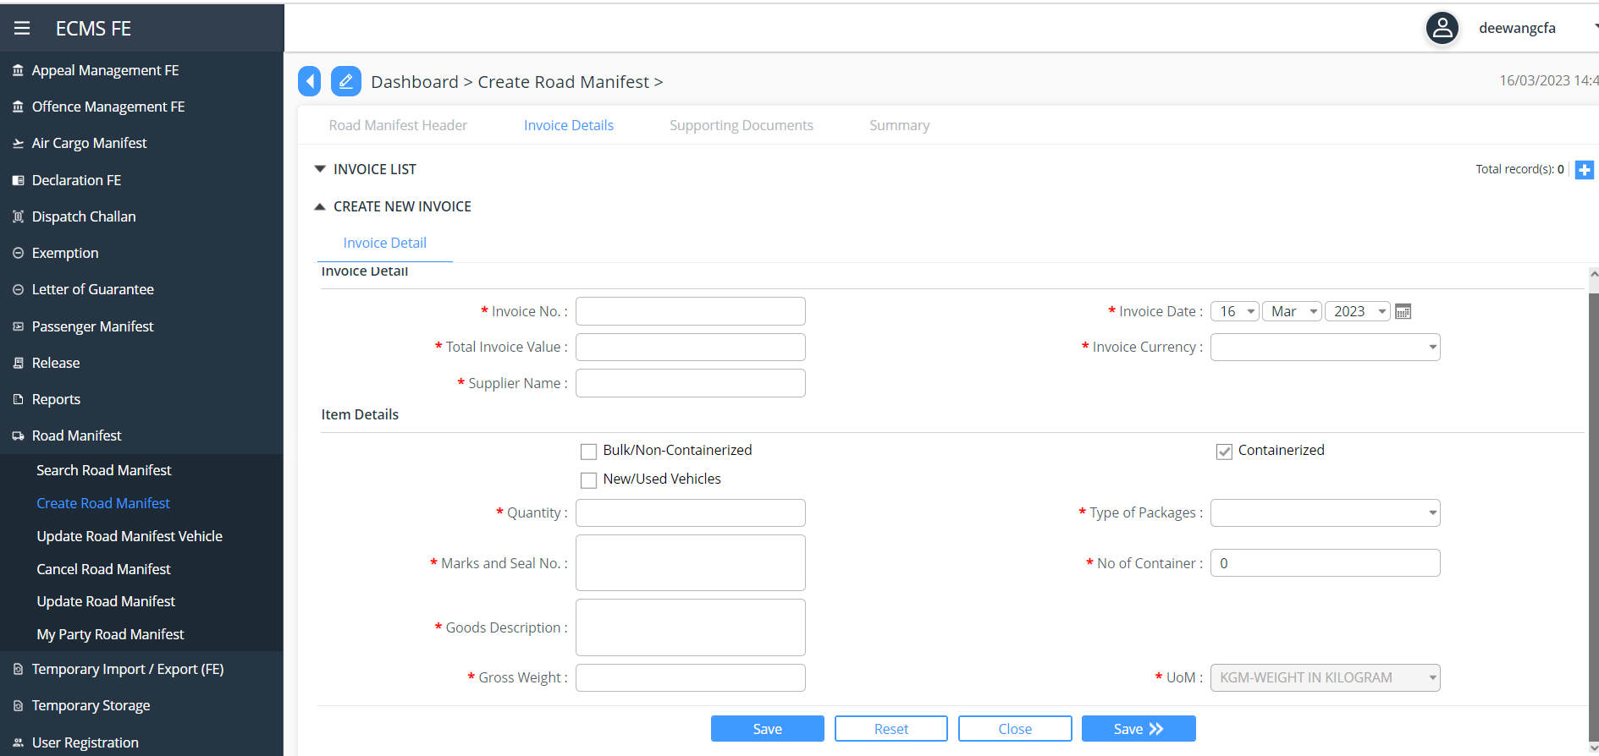

Screenshot of invoice for Container items

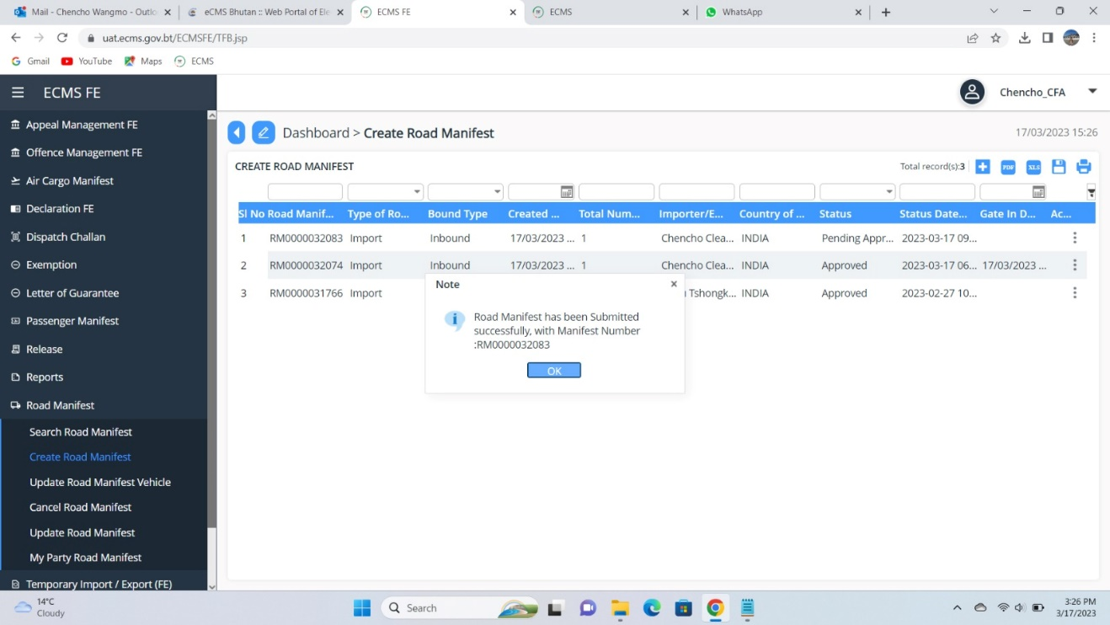

Screenshot for summary
- Add in the required documents:
- Summary Tab gives the overall information of the Road Manifest and Submit the same.:
- A Unique reference number is generated, which can be used for track application.

Reject/Approve Road manifest

The manifest is routed to a customs officer for approval. The customs officer selects the manifest and determines which of the following statuses will be applied:
- Approve
- Reject for Amendments
- Reject
if rejected for amendment, the user updates Manifest for re-submission.

Road Manifest Cancellation
The user creates a road manifest cancellation starting with the request header.

A manifest can be selected for cancellation if:
- it is not used in an active declaration.
- It is not yet included another cancellation request pending approval.
- it is not cancelled
- it is not in temporary storage
- vehicle has not yet entered the country (no gate-in reference number)

The Cancellation Manifest Number will have the following format:
CNCL<DDMMYYYY######>

Reject/Approve Road Manifest Cancellation
The request is routed to a customs officer for approval. The customs officer selects the request and determines which of the following statuses will be applied:
- Approve
- Reject

- Create Air Cargo Master Manifest

The user creates an air manifest starting with the header data. After entering all the mandatory inputs, the user can save the header data:

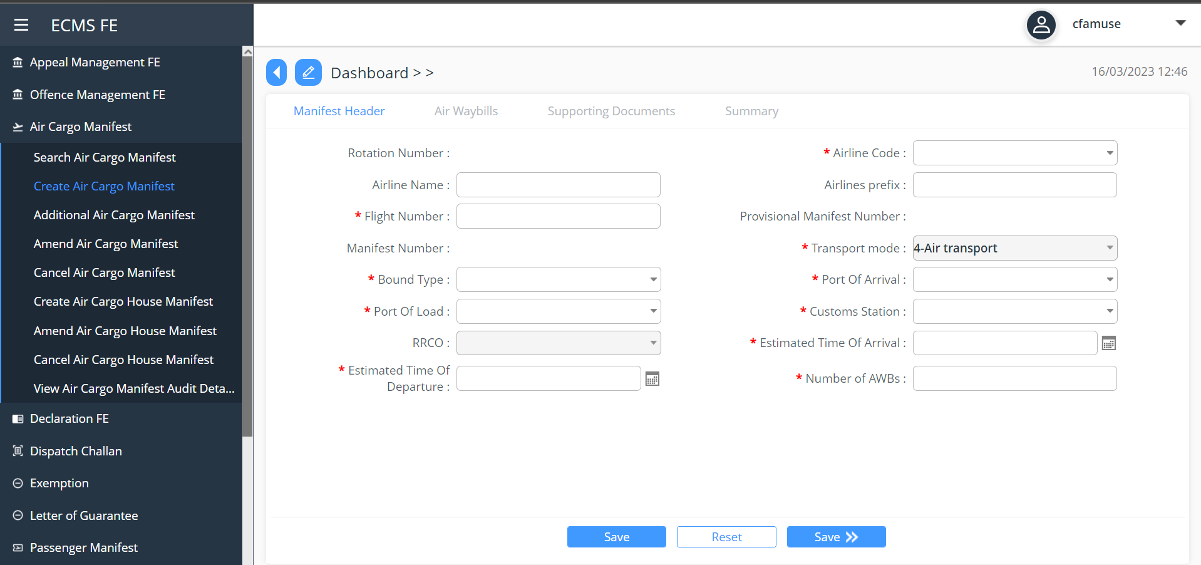
Screenshot for create air manifest.

The user can create air waybill/s only after the header data has been saved. The user can create as many AWBs in the system:

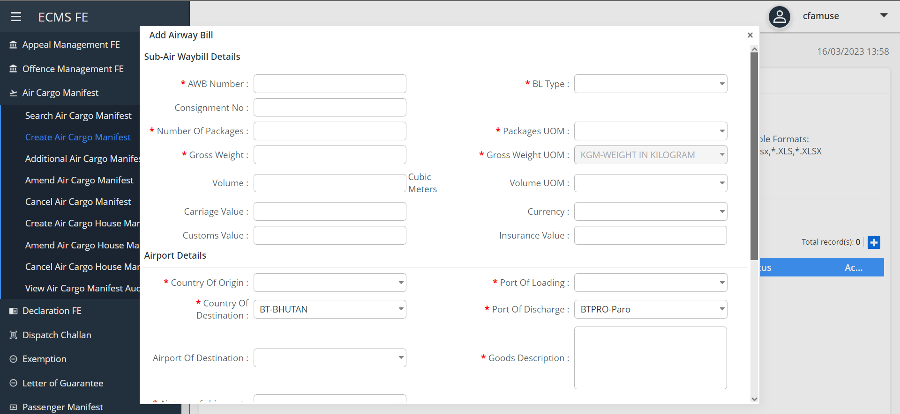
Screenshot for Airway Bills

The user submits the air manifest after creating the necessary AWBs:
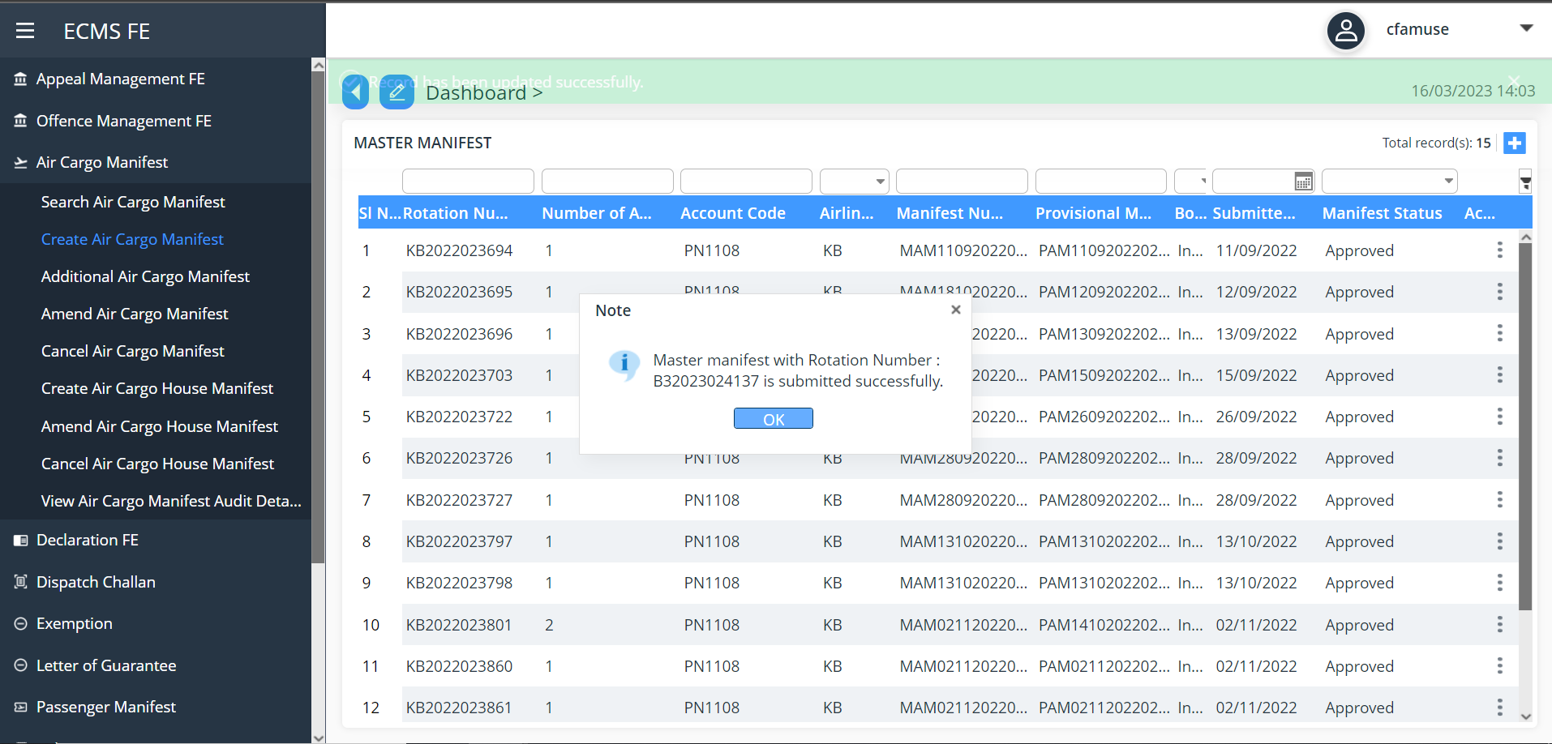
Screenshot for Air Manifest Submission

Approve Air Cargo Manifest

The manifest is routed to a customs officer for approval.
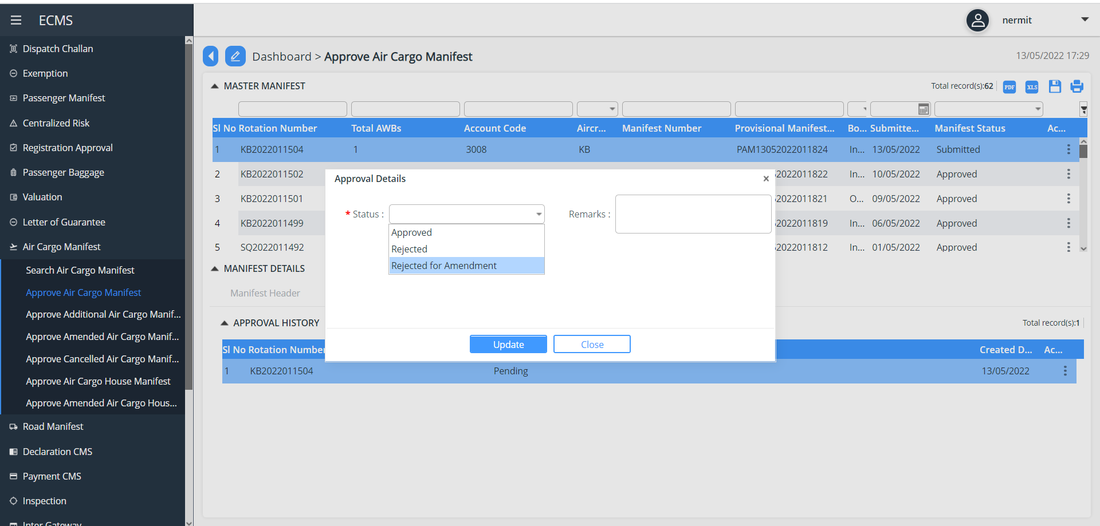
Screenshot for Air Cargo Manifest Approval

If the customs officer rejected the request/rejected the request for amendments, the user will be notified via email.

If the customs officer rejected the request for amendments, the request will be routed back to the user for update and re-submission.

If the customs officer approved the request, the request will have an Approved status.
Additional Air Cargo Manifest
The user creates an additional air manifest starting with the request header. The user selects a manifest created by the user’s party and with an Approved status.

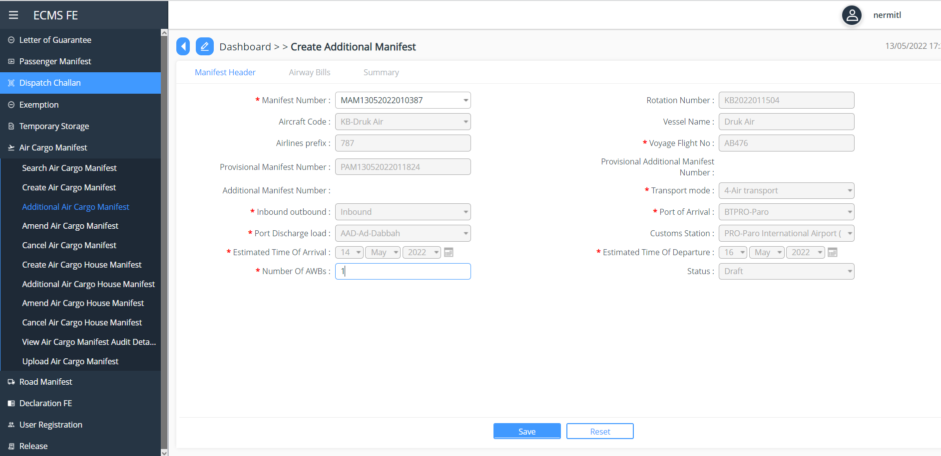
Screenshot for additional air manifest

Create Airwaybills
The user can create air waybill/s only after the header data has been saved. The user can create as many AWBs in the system.
OR
Upload Airwaybills. The user can also create an additional air manifest by uploading a file in eCMS
After the system uploads the manifest file, the system will create and save the corresponding additional air manifest header & AWBs with a Draft status.
A unique Provisional Additional Manifest Number will also be generated and saved along with the additional air manifest.

Submit Additional Air Cargo Manifest
The user submits the additional air manifest after creating the necessary AWBs.

Approve Additional Air Cargo Manifest
The manifest is routed to a customs officer for approval.
The Applicant is notified via email after the updating the status (Whether approved/Rejected/Resubmission)

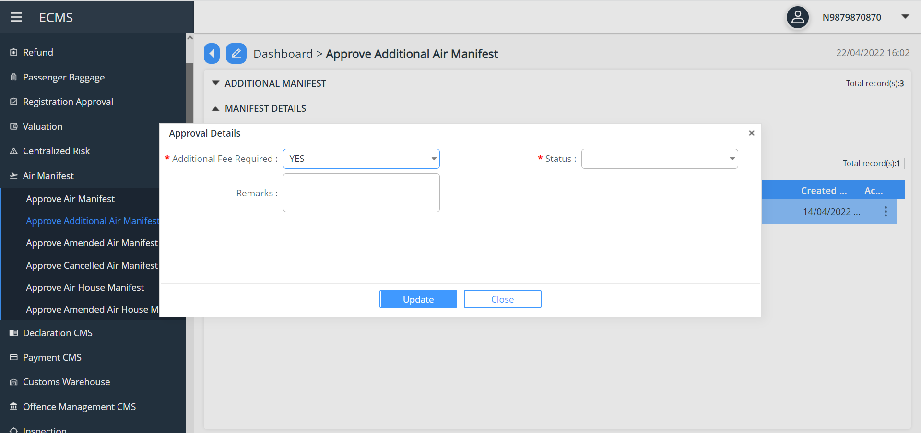
Screenshot Additional Air manifest approval

Request for Temporary Storage
The user can choose to move the consignment to temporary storage by submitting a Temporary Storage Request.

The temporary storage officer who receives the request will facilitate the actual movement of the consignment to the temporary storage.
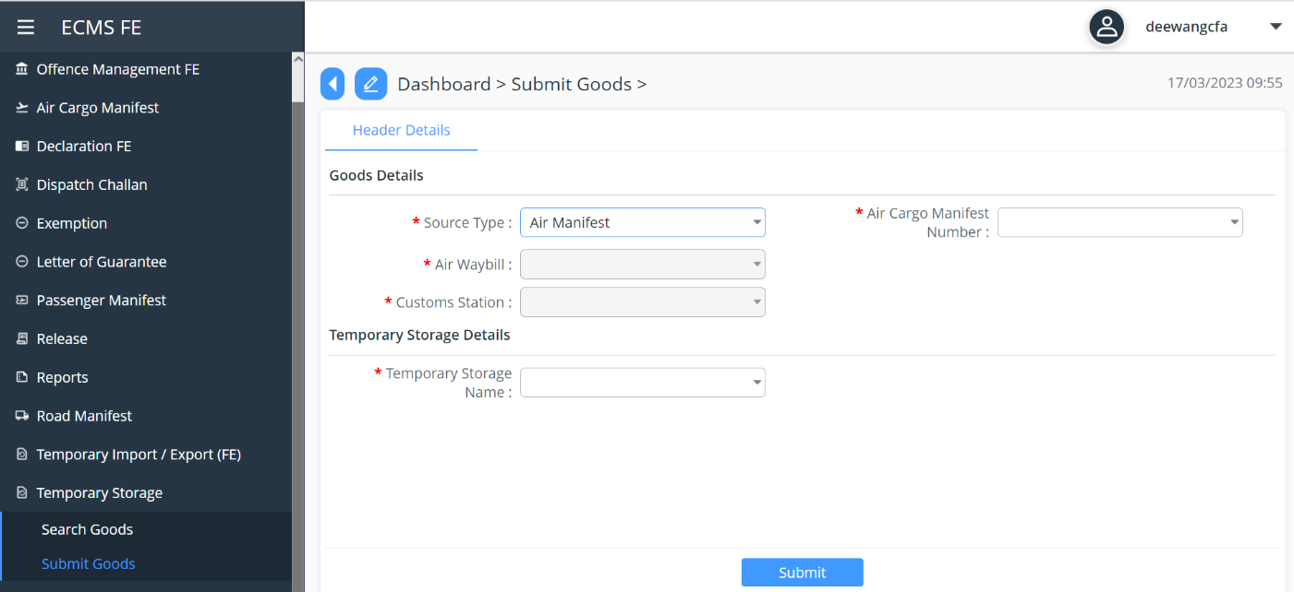
Screenshot for Temporary Storage Request

Passenger Manifest

Create Passenger Manifest Header:

eCMS will enable the user to submit passenger manifests through manual input or upload.
The user can also create a passenger manifest by uploading it as a file :
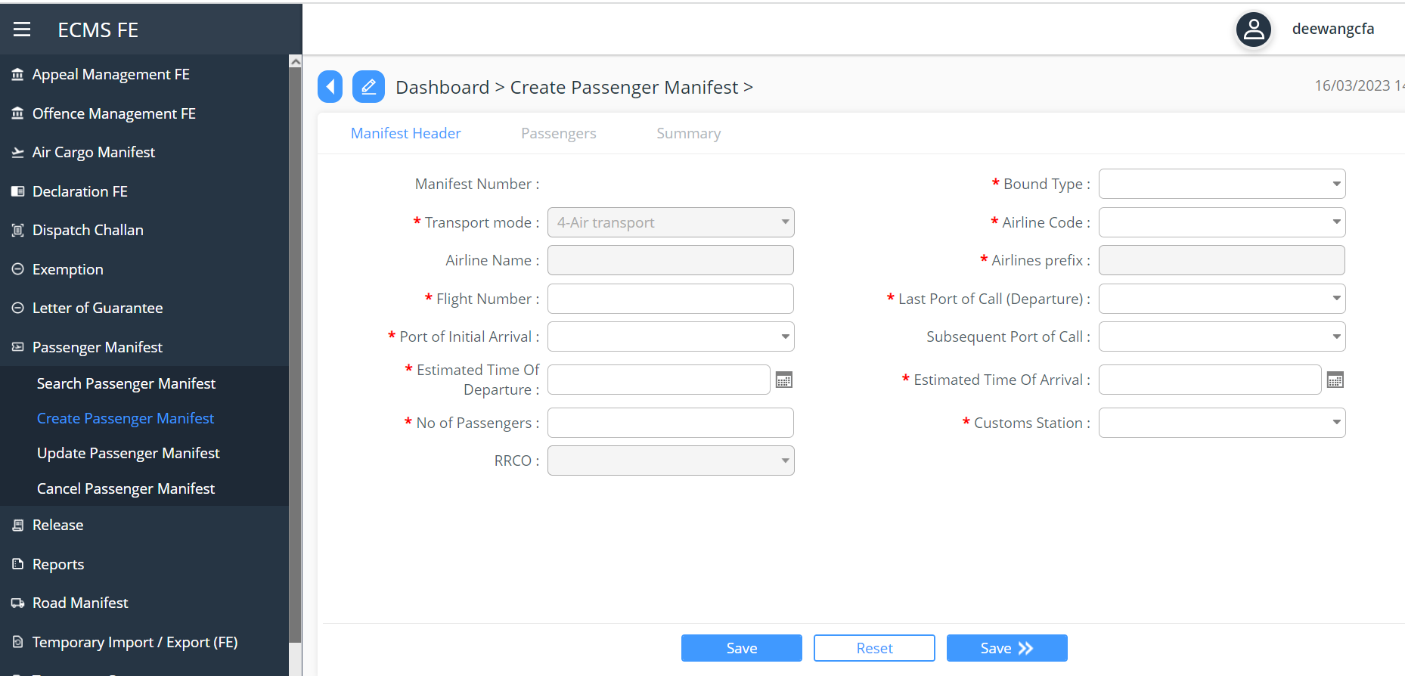
Screenshot to Create Passenger Manifest

Create OR Upload Passenger Manifest File
The user can create the passenger record only after the header data has been saved. The user can create as many passengers as possible in the system.

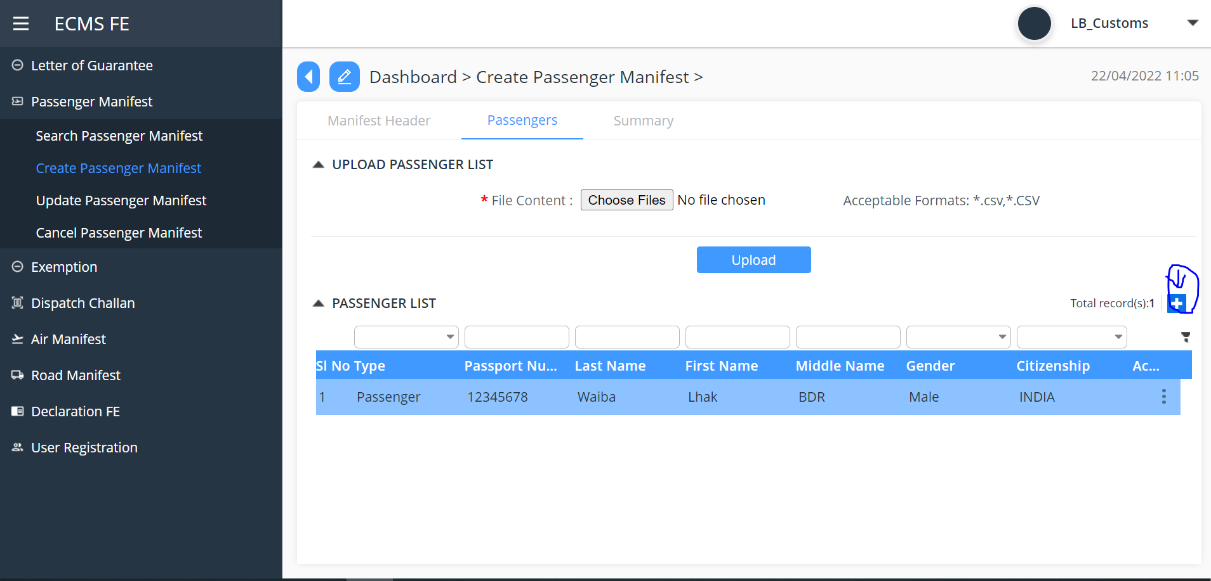
Screenshot Upload Passenger details

Submit Passenger Manifest
After the system uploads the manifest file via system integration, the system will create and save the corresponding manifest header & passenger list with a Draft status. A unique Manifest Number will also be generated and will be displayed so that the user can use it to access the record later and manually submit.
The Manifest Number will have the following format:
XXX<DDMMYYYY######>
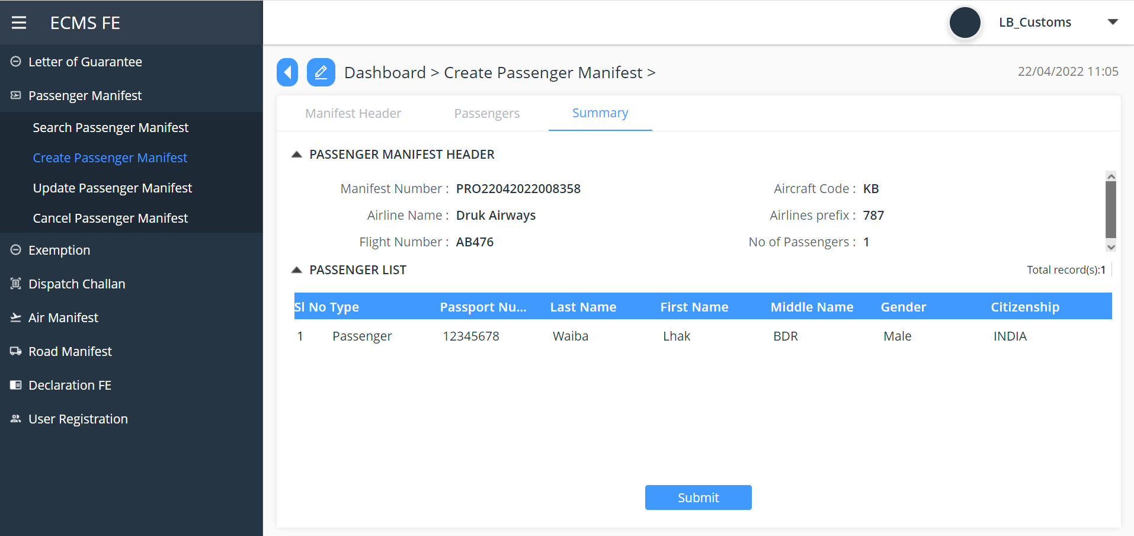
Screenshot for Submit Passenger manifest.

Reject/Approve Passenger Manifest
The manifest is routed to a customs officer for approval. The customs officer selects the manifest and determines which of the following statuses will be applied:
- Approve
- Reject for Amendments
- Reject
Update Passenger manifest
After the request was rejected for amendments, the user updates the passenger manifest to correct the issues that caused its rejection.

If the user updates the manifest header and then tries to save, it will be subjected to the same validation process mentioned above.
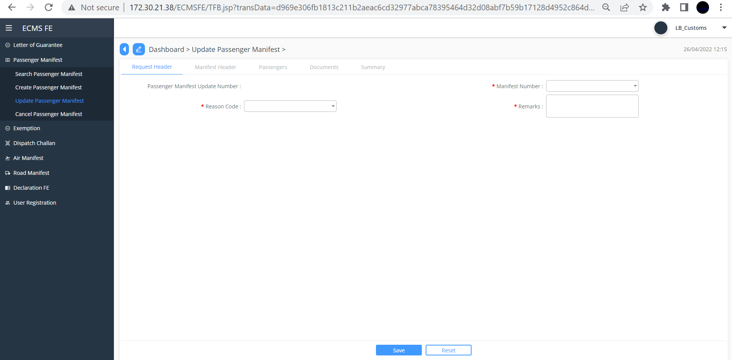
Screenshot Update passenger Manifest

Passenger Manifest Cancellation
Create Request Header: The user creates a passenger manifest cancellation starting with the request header. After entering all the mandatory inputs, the user can save the header data. If there are no validation issues, the system will generate a Cancellation Manifest Number and save the request header with a Draft status.

The Cancellation Manifest Number will have the following format:
CNCL<DDMMYYYY######>

Submit passenger Manifest Cancellation
The user submits the passenger manifest cancellation. If there are no validation issues, the system will save the request with a Pending Approval status and will route the request to a customs officer for approval.
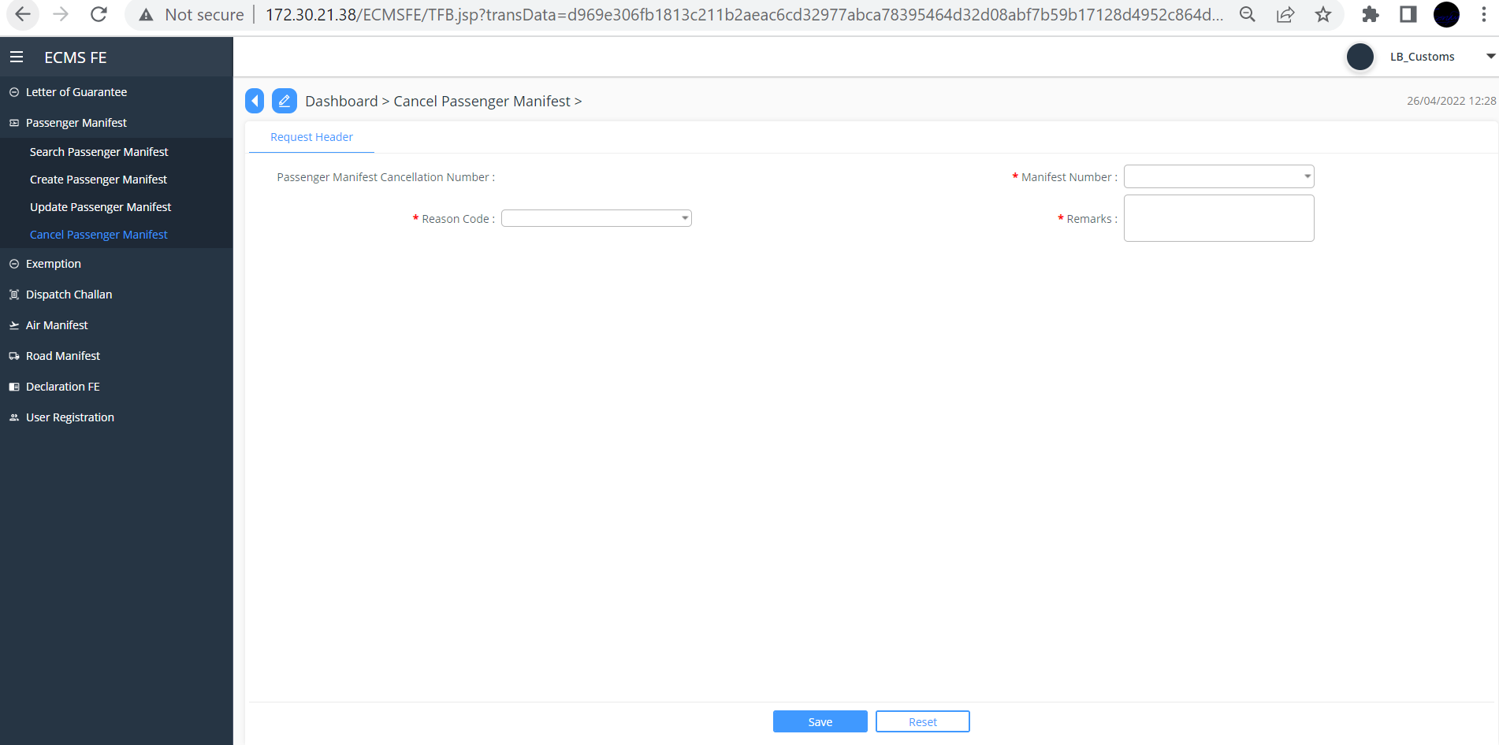
Screenshot passenger manifest cancellation

Approve or Reject Passenger manifest Cancellation
The request is routed to a customs officer for approval. The customs officer selects the request and determines which of the following statuses will be applied:
- Approve: if approved the status will be Approved
- Reject: Notify by email.

Dispatch Challan

The User creates and submits the Dispatch Challan as below,

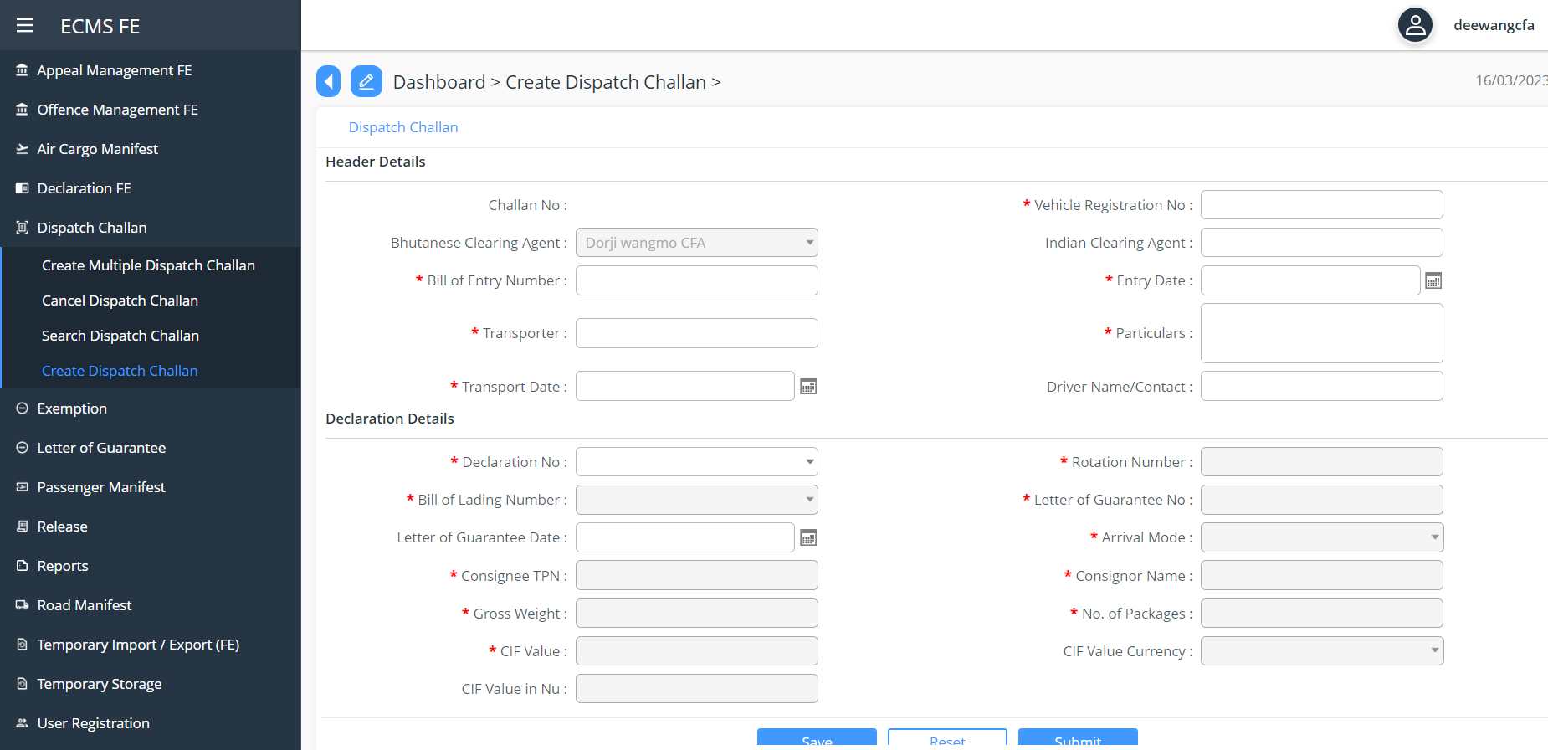
Screenshot to Create Dispatch Challan

Verify Dispatch Challan
Verifier will verify the dispatch challan and ascertain that all details are provided correctly. The verifier will have the following options:
- Approve: In this case, the challan will be approved and routed for consolidation.
- Reject: In this case, the challan shall be rejected.
- Recommend for Amendment: In this case, the challan shall be routed back to declarant for amendment and re-submission.

Temporary Storage admission
Goods that arrive by Air transport (AWB), Road (Manifest Invoice, the declarant/CFA must submit separate request to admit into temporary storage after the Air/Road manifest or Dispatch Challan has been approved.

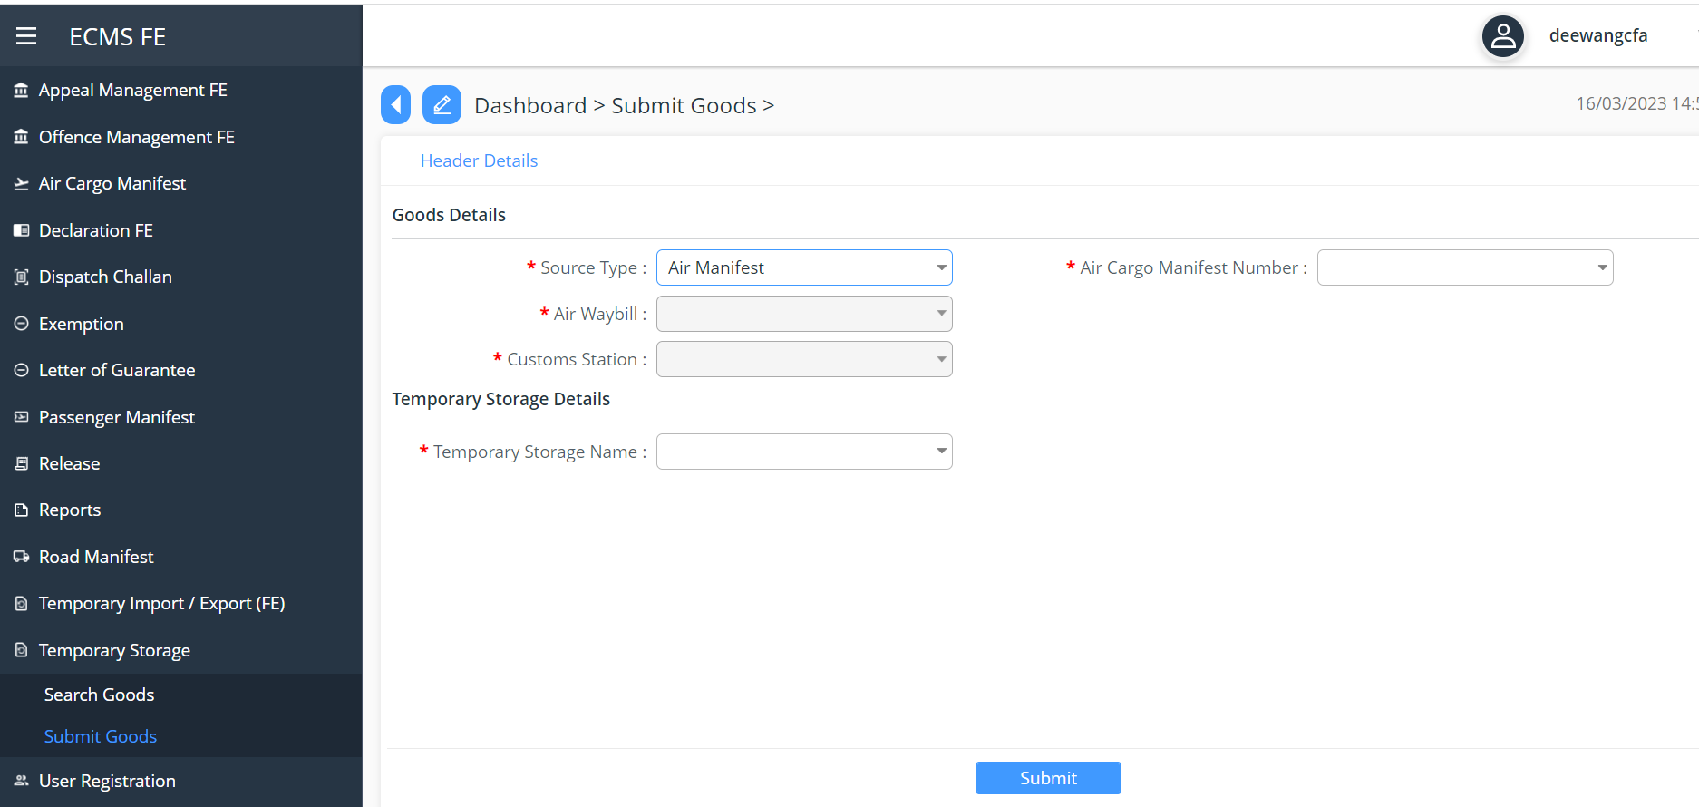
Screenshot for Temporary storage request in Air Manifest

Dependency Viewpoint

The Application module uses quite a few classes that share information and parameter among themselves to achieve the required functionalities. The package diagram of Application module is provided below.
logging
ORM
data
business
web
Manifest Controller
Config
exception
Manifest Service
Config
exception
servicehelpers
Manifest DAO
Config
exception
daohelpers
mysql-connector.jar
MySQL JDBC Driver
datasource
type
data
values

The Manifest Module uses quite a few classes that shares information and parameters among themselves. The Package Diagram for the Manifest Module, shown below, demonstrates that.

In the diagram, following dependencies between different packages are shown:
- web package is dependent on the business package,
- business package depend on the data package and
- ORM package depend on the data package.

These dependencies are explained below:
The Web package of Manifest Module contains the Manifest Controller class that reads configuration information from a config file and uses the class from the business package to delegate responsibilities. This Manifest Service class also gets its configuration information from a different config file and uses service helpers class for doing the business logic processing and Manifest DAO class from ORM package for achieving db-centric activities. The service helpers class provides business and data access logic with distributed transaction supports. The Manifest DAO class performs the assigned responsibilities depending on dao helpers class and reads a third config file to do so. The dao helpers class accesses the data from the database using a data source. The data source depends on the database driver (mysql-connector.jar), which is supplied externally. The data available in the data package is associated with type and values. All of the dao helpers class from ORM package, the service helpers class from business package and the Manifest Controller class from the web package may throw different exception classes at different points of time, which are redirected to the external logging sub-system. This logging sub-system is used for analysing the flow of control of the application.

System Database Schema

ER Diagram
(Example)
Air Cargo Manifest ER Diagram
Road Manifest ER Diagram

Field Details
Fields | Editable | Mandatory | Field Type | Field Length | Validation | REMARKS
Rotation No. | NO | NA | an | 35 |  | There is no rotation no in air manifest.
Aircraft Code | YES | YES | an | 20
Airline Name | NO | NA | an | 35
Airlines Prefix | NO | NA | an | 3
Flight No | YES | YES | an | 20
Manifest Number | NO | NA | an | 20
Mode of Transport | NO | NA | an | 4
Inbound Outbound | YES | YES | an | 6
Port Arrival | YES | YES | an | 10
Port of Load | YES | YES | an | 10
Customs Office | YES | NO | an | 17
Eta | YES | YES | timestamp | 6
Etd | YES | YES | timestamp | 6
No of AWBs | YES | YES | n | 15
Manifest Status | NO | NA | n | 15
AWB Number | YES | YES | an | 25 | Should be unique within the manifest
Bl Type | YES | YES | an | 5 | If Consolidator, then Consolidator Party Code (TPN) is mandatory
Consolidator Party Code (TPN) | NO | NA | an | 50
Consignment No | YES | NO | an | 25
No Of Pkgs | YES | YES | n | 8
Pkgs UOM | YES | NO | an | 3
Gross Weight | YES | YES | n | 16,3
Gross Weight UOM | YES | YES | an | 3
Volume | YES | NO | n | 14,3
Volume UOM | YES | NO | an | 4
Port Load | YES | YES | an | 6
Port Discharge | YES | YES | an | 6
Airport Of Dest | YES | NO | an | 35
Country of Orgin | YES | YES | an | 2
Country of Destination | YES | YES | an | 2
Goods Description | YES | YES | an | 3500
Air Type Of Shipment | YES | YES | an | 35
Consignee Name | YES | YES | an | 70
Consignee Address | YES | YES | an | 256
Consignee City | YES | NO | an | 35
Consignee Coutnry | YES | YES | an | 2
Consignor Name | YES | YES | an | 70
Consignor Address | YES | YES | an | 256
Consignor City | YES | NO | an | 35
Consignor Country | YES | YES | an | 2
Air Cargo manifest

Road Manifest Field Details

Section | Fields | Editable | Mandatory | Field Type | Field Length
Road Manifest Header | Manifest Number | NO | NA | an | 20
 | Bound Type | YES | NO | n | 15
 | Mode of Transport | NO | NA | an | 15
 | Estimated Time of Arrival | YES | YES | timestamp | 6
 | Entry Point | YES | YES | an | 5
 | Arrival Point | YES | YES | an | 5
 | Border Office | YES | YES | n | 15
 | Regime | YES | YES | n | 15
 | Agent Name | YES | YES | an | 200
 | Total Invoice Value | YES | YES | n | 15,2
 | No of Invoice | YES | NO | n | 15
 | Manifest Status | NO | NA | n | 15
 | Gate-In Date | NO | NO | timestamp | 14
 | Gate-In Reference Number | NO | NO | timestamp | 14
Invoice Details | Invoice No. | YES | NO | an | 20
 | Invoice Date | YES | YES | timestamp | 6
 | Invoice Item Value | YES | YES | n | 15,2
 | Term Type | YES | YES | n | 15
 | Item Indicator | YES | NO | an | 100
 | Number of Packages | YES | YES | n | 15
 | Marks and Number | YES | NO | an | 200
 | Goods Description | YES | NO | an | 200
 | Freight Type | YES | NO | n | 15
 | Freight Amount | YES | YES | n | 15,2
 | Currency | YES | YES | n | 15
 | Gross Weight | YES | NO | n | 15,3
 | Volume | YES | NO | n | 15,3
 | Importer Id | YES | NO | n | 15
 | Importer Address | YES | NO | an | 200
 | Importer Contact Number | YES | NO | an | 50
 | Exporter Id | YES | NO | n | 15
 | Exporter Address | YES | NO | an | 200
 | Importer Contact Number | YES | NO | an | 50
Truck Detail | Trailer No. | YES | NO | an | 50
 | Registration No. | YES | NO | an | 50
 | Means of Transport | YES | NO | n | 15
 | Invoice Date | YES | NO | timestamp | 6
 | Remarks | YES | NO | an | 200
 | Goods Description | YES | NO | an | 200
 | Telephone number | YES | NO | an | 50
Container | Container No | YES | YES | an | 17
 | Number of Packages | YES | YES | n | 8
 | Container Type | YES | YES | an | 10
 | Load Status | YES | NO | an | 2
 | Tare Weight | YES | YES | n | 16,3
 | Net Weight | YES | YES | n | 16,3
 | Gross Weight | YES | YES | n | 16,3
 | Own Container | YES | YES | an | 5
 | Seal No | YES | YES | an | 35
 | Container ISO Code | YES | YES | an | 50
 | Container Size | YES | YES | n | 15
 | Maximum Payload | YES | YES | n | 15,3
 | Tare Weight UOM | NO | YES | an | 3
 | Net Weight UOM | NO | YES | an | 3
 | Gross Weight UOM | NO | YES | an | 3
Vehicle | Chasis No | YES | YES | an | 50
 | Make | YES | YES | an | 50
 | Model | YES | YES | an | 50

